SIMATS ENGINEERING
ASSESSMENT TOOL 1

COURSE NAME: CSA04 COURSE CODE: Operating Systems

COURSE OUTCOME COVERED

CO4: Optimize various file allocation strategies and disk scheduling algorithms to identify optimal methods for enhancing system performance.

Assessment Tool Weightage: 40%

Dr VIMAL V R

QUESTIONS: 5 Total Marks:25

Annexure A

CODING CHALLENGE/HACKATHON

Code of Conduct:

I _Sruthi Rithika P(192521407) (Name / Reg No) certify that this submission is my original work and that I have adhered to the guidelines specified for this assessment.
I understand that any violation of academic integrity rules will result in disciplinary action.

Signature of the student: Sruthi Rithika P

Annexure A

CODING CHALLENGE

S.No | Coding Challenge Questions | Marks
1 | Write a program to simulate the three file allocation methods—Contiguous, Linked, and Indexed. The program should accept inputs including the total disk size (number of blocks), the file size(number of blocks required),and the allocation method (1forContiguous, 2for Linked, 3 for Indexed). Based on the selected method, the program must allocate disk blocks accordingly, display the allocated block numbers, and handle fragmentation scenarios, particularly when contiguous allocation fails due to insufficient continuous space. The output should show the list of allocated blocks or an appropriate error message if allocation is not possible. Ensure that built-in memory allocation functions are not used, and assume that disk blocks are numbered starting from 0. | 5
2 | Develop a program to manage free disk space using a bitmap technique. The program should accept inputs including the total number of disk blocks, the initial bitmap (where 0 represents free and 1 represents allocated), and a request for allocation specifying the number of blocks required. The program must identify and allocate free blocks efficiently, update the bitmap after allocation, and also support deallocation of specified blocks with appropriate bitmap updates. The output should display the updated bitmap after allocation and deallocation operations. Ensure that the program efficiently searches for free blocks and properly handles  Cases where sufficient space is not available. | 5
3 | Implement a program that simulates at least three disk scheduling algorithms: FCFS, SSTF, and SCAN. The program should take as input the disk request queue, the initial head position, and the disk size. It must compute the total seek time for each algorithm, display the order in which disk requests are serviced, and compare their performance. The output should include the seek sequence and total seek time for each algorithm, along with identification of the best-  Performing algorithm based on minimum seek time. | 5
4 | Write a program to implement the C-SCAN and LOOK disk scheduling algorithms. The program should accept inputs including the request queue, the initial head position, and the direction of head movement (left or right). It must simulate both algorithms, calculate the total head movement required to service all requests, and compare their efficiency. The output should display the seek sequence, total head movement, and a conclusion indicating which algorithm performs better along with a brief justification. Optionally, the program may include  a graphical visualization of head movement. | 5
5 | Design a program that integrates file allocation strategies with disk scheduling techniques to optimize system performance. The program should accept inputs such as the total number of disk blocks, file size (number of blocks required), disk request queue, initial head position, allocation method (Contiguous or Indexed), and disk scheduling method (FCFS or SSTF). It must allocate disk blocks based on the chosen allocation strategy, simulate disk scheduling to access the allocated blocks, calculate the total seek time, and compare performance across different combinations. The output should display allocated blocks, seek sequence, total seek time, and identify the best combination of allocation and scheduling methods. Ensure the program handles allocation failures, avoids duplicate block allocation, and maintains efficient scheduling. | 5

RUBRICS FOR CALCULATION

Criteria | Weightage | Level 4 (Exemplary) | Level 3 (Proficient) | Level 2 (Developing) | Level 1 (Beginning)
Problem Understanding | 20% | Clearly understands problem constraints, edge cases, and competitive requirements | Understands problem with minor gaps in constraints | Partial understanding; misses key constraints | Misinterprets problem or constraints
Algorithm | 25% | Selects optimal algorithm with best time and space complexity for competitive constraints | Uses efficient algorithm with minor scope for improvement | Uses basic/inefficient approach | No clear algorithmic approach
Code Implementation | 20% | Writes correct, efficient, and clean code that passes all constraints | Code works with minor errors or inefficiencies | Partially correct code; fails for some cases | Code does not execute or gives incorrect results
Competitive Performance | 20% | Solves problem within time limits and handles large inputs effectively | Solves within acceptable time with minor delays | Struggles with time limits or larger inputs | Unable to solve within time constraints
Test Case Handling | 15% | Handles all test cases including edge and hidden cases | Handles most test cases | Misses important edge cases | Fails on multiple test cases

Q1)
Aim
To write a C program to simulate the three file allocation methods: Contiguous, Linked, and Indexed allocation. The program allocates disk blocks based on the selected method and displays the allocated block numbers. It also detects fragmentation and reports an error when contiguous allocation is not possible.
Concept / Description
- Contiguous Allocation
  - A file occupies consecutive disk blocks.
  - It provides fast access because blocks are adjacent.
  - Allocation fails if there are not enough continuous free blocks, even when enough total free blocks exist.
  - This situation is called external fragmentation.
- Linked Allocation
  - File blocks can be located anywhere on the disk.
  - Each block is logically connected to the next block.
  - Therefore, continuous free space is not required.
- Indexed Allocation
  - An index block stores the addresses of all blocks belonging to the file.
  - File blocks can be allocated anywhere on the disk.
  - The program reserves one free block as the index block.
Algorithm
- Read the total number of disk blocks.
- Initialize all disk blocks as free.
- Read the file size in blocks.
- Ask the user to select:
  - 1 – Contiguous
  - 2 – Linked
  - 3 – Indexed
- For contiguous allocation:
  - Search for consecutive free blocks.
  - If found, allocate them.
  - Otherwise, display an error indicating insufficient continuous space.
- For linked allocation:
  - Search for any required number of free blocks.
  - Allocate them sequentially in the linked list.
- For indexed allocation:
  - Reserve one block as the index block.
  - Allocate the required data blocks from the remaining free blocks.
- Display the allocated block numbers.
- End the program.
C Program

#include <stdio.h>

#define MAX 100

int disk[MAX];

void initializeDisk(int n)
{
int i;
for (i = 0; i < n; i++)
disk[i] = 0; /* 0 = free, 1 = allocated */
}

/* Contiguous Allocation */
void contiguous(int n, int fileSize)
{
int i, j, start = -1;
int count;

for (i = 0; i <= n - fileSize; i++)
{
count = 0;

for (j = i; j < i + fileSize; j++)
{
if (disk[j] == 0)
count++;
else
break;
}

if (count == fileSize)
{
start = i;
break;
}
}

if (start == -1)
{
printf("\nContiguous allocation failed.\n");
printf("Enough total free blocks may exist, but continuous space is not available.\n");
return;
}

printf("\nAllocated blocks using Contiguous Allocation:\n");

for (i = start; i < start + fileSize; i++)
{
disk[i] = 1;
printf("%d ", i);
}

printf("\n");
}

/* Linked Allocation */
void linked(int n, int fileSize)
{
int i, count = 0;

printf("\nAllocated blocks using Linked Allocation:\n");

for (i = 0; i < n && count < fileSize; i++)
{
if (disk[i] == 0)
{
disk[i] = 1;

printf("%d", i);

count++;

if (count < fileSize)
printf(" -> ");
}
}

if (count < fileSize)
{
printf("\nAllocation failed: Not enough free blocks.\n");
}
else
{
printf("\n");
}
}

/* Indexed Allocation */
void indexed(int n, int fileSize)
{
int i, count = 0;
int indexBlock = -1;

/* Find an index block */
for (i = 0; i < n; i++)
{
if (disk[i] == 0)
{
indexBlock = i;
disk[i] = 1;
break;
}
}

if (indexBlock == -1)
{
printf("\nIndexed allocation failed: No free index block.\n");
return;
}

printf("\nIndex block: %d\n", indexBlock);
printf("Allocated data blocks:\n");

for (i = 0; i < n && count < fileSize; i++)
{
if (disk[i] == 0)
{
disk[i] = 1;
printf("%d ", i);
count++;
}
}

if (count < fileSize)
{
printf("\nAllocation failed: Not enough free blocks.\n");

/* Release index block if allocation fails */
disk[indexBlock] = 0;
}
else
{
printf("\n");
}
}

int main()
{
int n, fileSize, choice;

printf("Enter total number of disk blocks: ");
scanf("%d", &n);

if (n <= 0 || n > MAX)
{
printf("Invalid disk size. Enter a value between 1 and %d.\n", MAX);
return 0;
}

initializeDisk(n);

printf("Enter file size (number of blocks required): ");
scanf("%d", &fileSize);

if (fileSize <= 0 || fileSize > n)
{
printf("Invalid file size.\n");
return 0;
}

printf("\nFile Allocation Methods\n");
printf("1. Contiguous Allocation\n");
printf("2. Linked Allocation\n");
printf("3. Indexed Allocation\n");

printf("Enter your choice: ");
scanf("%d", &choice);

switch (choice)
{
case 1:
contiguous(n, fileSize);
break;

case 2:
linked(n, fileSize);
break;

case 3:
/*
* Indexed allocation requires one extra
* block for the index.
*/
if (fileSize + 1 > n)
{
printf("\nIndexed allocation failed.\n");
printf("An additional block is required for the index.\n");
}
else
{
indexed(n, fileSize);
}
break;

default:
printf("\nInvalid allocation method.\n");
}

return 0;
}

OUTPUT
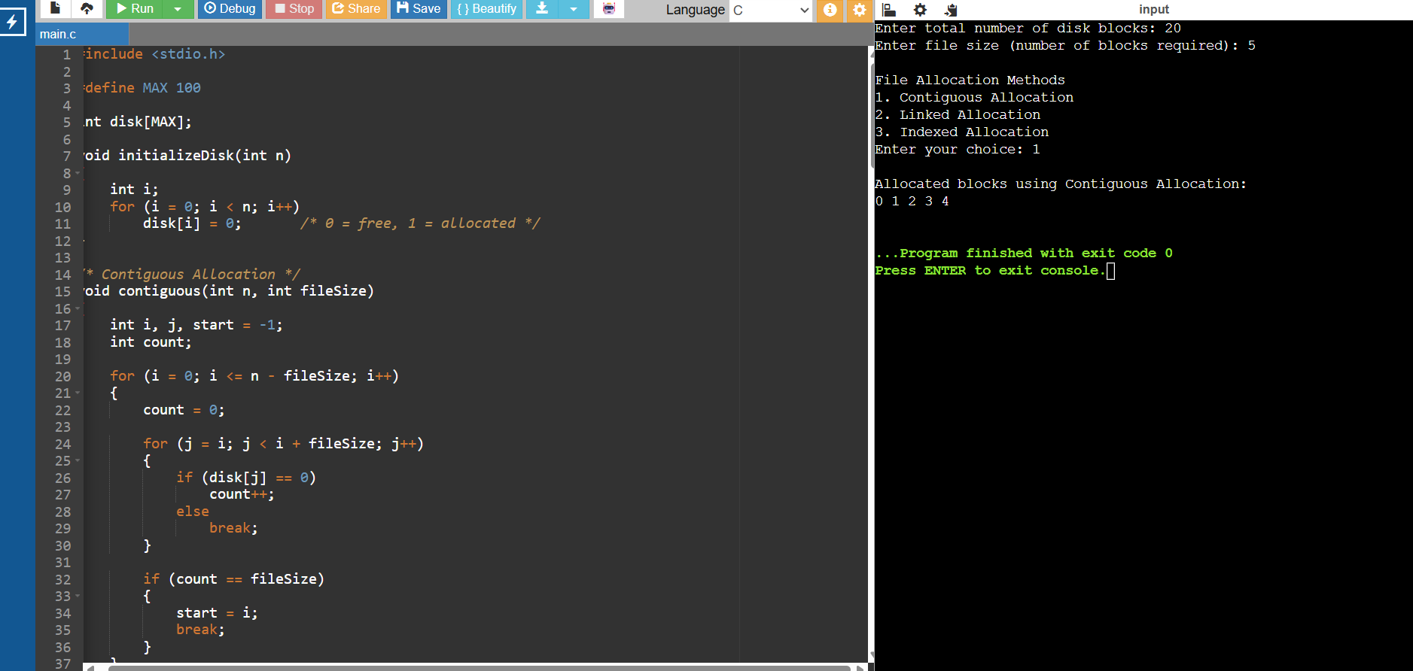

Result
Thus, the Contiguous, Linked, and Indexed file allocation methods were successfully simulated. The program displays the allocated disk blocks and handles allocation failure caused by insufficient free space or fragmentation. No built-in dynamic memory allocation functions such as malloc() or calloc() are used.

Q2)
Aim
To develop a C program to manage free disk space using the Bitmap technique. The program identifies free disk blocks using a bitmap, allocates the required number of blocks, updates the bitmap, and supports deallocation of specified blocks.
Concept
In bitmap-based free-space management, each disk block is represented by one bit:
- 0 → Block is free
- 1 → Block is allocated
For allocation, the program scans the bitmap and finds free blocks. Once allocated, their values are changed from 0 to 1.
For deallocation, the specified allocated blocks are changed from 1 to 0.
This technique makes free-space management simple and allows the operating system to quickly determine which blocks are available.
Algorithm
- Read the total number of disk blocks.
- Read the initial bitmap.
- Display the initial bitmap.
- Read the number of blocks required for allocation.
- Scan the bitmap from the beginning.
- Identify free blocks (0).
- Allocate the required number of free blocks by changing 0 to 1.
- If enough free blocks are unavailable, display an error message.
- Display the updated bitmap.
- Read the number of blocks to deallocate.
- Read the block numbers to be deallocated.
- Change those blocks from 1 to 0.
- Display the final updated bitmap.
- Stop.
C Program
#include <stdio.h>

#define MAX 100

int main()
{
int bitmap[MAX];
int n, i;
int required;
int count = 0;
int deallocCount;
int block;

printf("Enter total number of disk blocks: ");
scanf("%d", &n);

if (n <= 0 || n > MAX)
{
printf("Invalid number of blocks.\n");
return 0;
}

printf("Enter initial bitmap (0 = Free, 1 = Allocated):\n");

for (i = 0; i < n; i++)
{
scanf("%d", &bitmap[i]);

if (bitmap[i] != 0 && bitmap[i] != 1)
{
printf("Invalid bitmap value.\n");
return 0;
}
}

printf("\nInitial Bitmap:\n");

for (i = 0; i < n; i++)
{
printf("%d ", bitmap[i]);
}

/* Allocation */
printf("\n\nEnter number of blocks required: ");
scanf("%d", &required);

/* Count free blocks */
count = 0;

for (i = 0; i < n; i++)
{
if (bitmap[i] == 0)
{
count++;
}
}

if (required <= 0)
{
printf("Invalid allocation request.\n");
}
else if (required > count)
{
printf("\nAllocation failed.\n");
printf("Free blocks available = %d\n", count);
printf("Blocks required = %d\n", required);
}
else
{
printf("\nAllocated block numbers:\n");

count = 0;

for (i = 0; i < n; i++)
{
if (bitmap[i] == 0 && count < required)
{
bitmap[i] = 1;
printf("%d ", i);
count++;
}
}

printf("\n\nBitmap after allocation:\n");

for (i = 0; i < n; i++)
{
printf("%d ", bitmap[i]);
}
}

/* Deallocation */
printf("\n\nEnter number of blocks to deallocate: ");
scanf("%d", &deallocCount);

if (deallocCount > 0)
{
printf("Enter block numbers:\n");

for (i = 0; i < deallocCount; i++)
{
scanf("%d", &block);

if (block < 0 || block >= n)
{
printf("Invalid block number: %d\n", block);
}
else if (bitmap[block] == 0)
{
printf("Block %d is already free.\n", block);
}
else
{
bitmap[block] = 0;
printf("Block %d deallocated.\n", block);
}
}
}

printf("\nFinal Bitmap:\n");

for (i = 0; i < n; i++)
{
printf("%d ", bitmap[i]);
}

printf("\n");

return 0;
}

OUTPUT
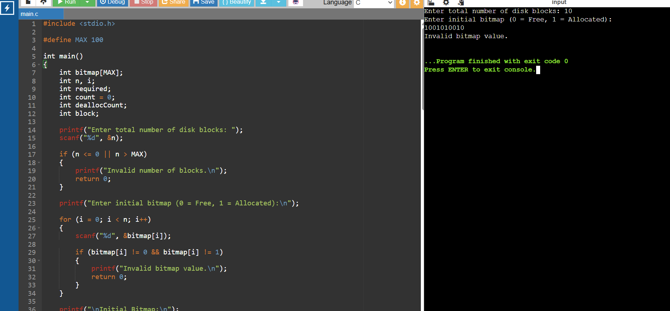

Result
Thus, the Bitmap-based free-space management technique was successfully implemented. The program efficiently searches for free blocks, performs allocation, updates the bitmap, supports deallocation, and handles cases where sufficient free disk space is unavailable.

Q3)
Aim
To implement and simulate three disk scheduling algorithms — FCFS, SSTF, and SCAN — and calculate the total seek time for each algorithm. The program also displays the seek sequence and identifies the algorithm with the minimum seek time.
Concept
1. FCFS – First Come First Serve
- Requests are serviced in the same order in which they arrive.
- It is simple to implement.
- It may result in a large total head movement.
2. SSTF – Shortest Seek Time First
- The request closest to the current head position is serviced first.
- It generally reduces seek time compared with FCFS.
- A request far from the head may suffer starvation.
3. SCAN – Elevator Algorithm
- The disk head moves in one direction and services requests along the way.
- When it reaches the end of the disk, it reverses direction.
- It provides more uniform waiting time.
Algorithm
- Read the number of disk requests.
- Read the request queue.
- Read the initial head position.
- Read the disk size.
- Apply FCFS and calculate total head movement.
- Apply SSTF by repeatedly selecting the nearest unvisited request.
- Apply SCAN by servicing requests in one direction and then reversing.
- Display the seek sequence and total seek time.
- Compare the three seek times.
- Display the algorithm with minimum seek time.
C Program
#include <stdio.h>

int fcfsTime;
int sstfTime;
int scanTime;

printf("Enter disk size: ");
scanf("%d", &diskSize);

if (diskSize <= 0)
{
printf("Invalid disk size.\n");
return 0;
}

printf("Enter number of disk requests: ");
scanf("%d", &n);

if (n <= 0 || n > MAX)
{
printf("Invalid number of requests.\n");
return 0;
}

printf("Enter disk request queue:\n");

for (i = 0; i < n; i++)
{
scanf("%d", &request[i]);

if (request[i] < 0 || request[i] >= diskSize)
{
printf("Invalid request: %d\n", request[i]);
return 0;
}
}

printf("Enter initial head position: ");
scanf("%d", &head);

if (head < 0 || head >= diskSize)
{
printf("Invalid head position.\n");
return 0;
}

printf("\n====================================");
printf("\n DISK SCHEDULING SIMULATION");
printf("\n====================================\n");

/* FCFS */
fcfsTime = fcfs(request, n, head);

/* SSTF */
sstfTime = sstf(request, n, head);

/* SCAN */
scanTime = scan(request, n, head, diskSize);

/* Comparison */
printf("\n====================================");
printf("\n PERFORMANCE");
printf("\n====================================\n");

printf("FCFS Total Seek Time = %d\n", fcfsTime);
printf("SSTF Total Seek Time = %d\n", sstfTime);
printf("SCAN Total Seek Time = %d\n", scanTime);

if (fcfsTime <= sstfTime && fcfsTime <= scanTime)
{
printf("\nBest Performing Algorithm: FCFS");
}
else if (sstfTime <= fcfsTime && sstfTime <= scanTime)
{
printf("\nBest Performing Algorithm: SSTF");
}
else
{
printf("\nBest Performing Algorithm: SCAN");
}

printf("\n");

return 0;
}

OUTPUT
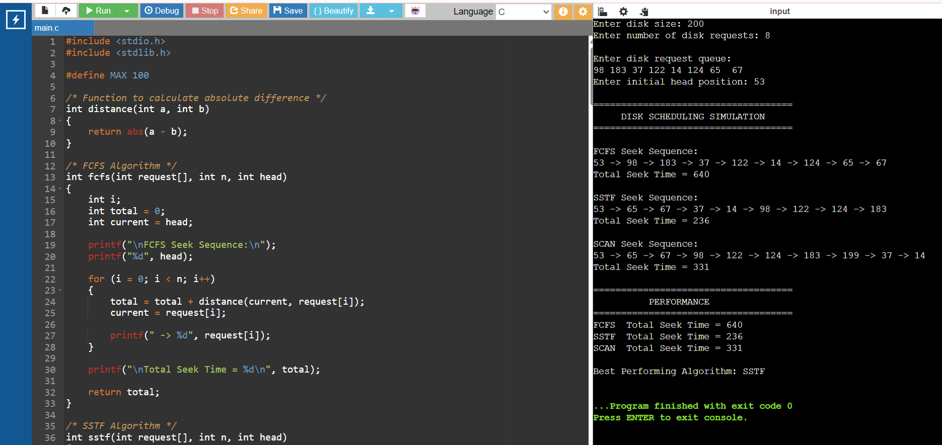

Result
Thus, the FCFS, SSTF, and SCAN disk scheduling algorithms were successfully implemented. The program displays the seek sequence and calculates the total seek time for each algorithm. The algorithm having the minimum seek time is identified as the best-performing algorithm for the given request queue.

Q4)

Aim
To implement C-SCAN (Circular SCAN) and LOOK disk scheduling algorithms and compare their performance based on total head movement.
Concept
C-SCAN
- The disk head moves in only one direction.
- It services requests while moving in that direction.
- When it reaches the end of the disk, it jumps to the opposite end without servicing requests during the return.
- It then continues in the same direction.
LOOK
- Similar to SCAN, but the head does not travel to the physical end of the disk unless there is a request there.
- It reverses direction after servicing the last request in the current direction.
- Therefore, LOOK usually results in less head movement than SCAN-type algorithms.
Algorithm
C-SCAN
- Read the request queue, head position, disk size, and direction.
- Sort the requests.
- If direction is right:
  - Service requests greater than the head.
  - Move to the last disk block.
  - Jump to block 0.
  - Service remaining requests.
- If direction is left:
  - Service requests smaller than the head.
  - Move to block 0.
  - Jump to the last disk block.
  - Service remaining requests.
- Calculate total head movement.
LOOK
- Sort the request queue.
- If direction is right:
  - Service all requests greater than the head.
  - Reverse direction.
  - Service remaining requests.
- If direction is left:
  - Service all requests smaller than the head.
  - Reverse direction.
  - Service remaining requests.
- Calculate total head movement.
- Compare C-SCAN and LOOK.
C Program
#include <stdio.h>

printf("Enter request queue:\n");

for (i = 0; i < n; i++)
{
scanf("%d", &request[i]);

if (request[i] < 0 || request[i] >= diskSize)
{
printf("Invalid request: %d\n", request[i]);
return 0;
}
}

printf("Enter initial head position: ");
scanf("%d", &head);

if (head < 0 || head >= diskSize)
{
printf("Invalid head position.\n");
return 0;
}

printf("Enter direction (L for Left, R for Right): ");
scanf(" %c", &direction);

if (direction != 'L' && direction != 'l' &&
direction != 'R' && direction != 'r')
{
printf("Invalid direction.\n");
return 0;
}

printf("\n====================================");
printf("\n DISK SCHEDULING SIMULATION");
printf("\n====================================\n");

/* C-SCAN */
cscanTime = cscan(request, n, head, diskSize, direction);

/* LOOK */
lookTime = look(request, n, head, direction);

/* Comparison */
printf("\n====================================");
printf("\n COMPARISON");
printf("\n====================================\n");

printf("C-SCAN Total Head Movement = %d\n", cscanTime);
printf("LOOK Total Head Movement = %d\n", lookTime);

if (cscanTime < lookTime)
{
printf("\nConclusion: C-SCAN performs better.\n");
printf("It requires less total head movement for this request queue.\n");
}
else if (lookTime < cscanTime)
{
printf("\nConclusion: LOOK performs better.\n");
printf("It requires less head movement because it does not travel\n");
printf("to the physical end of the disk unnecessarily.\n");
}
else
{
printf("\nConclusion: Both algorithms have equal performance.\n");
}

return 0;
}

OUTPUT
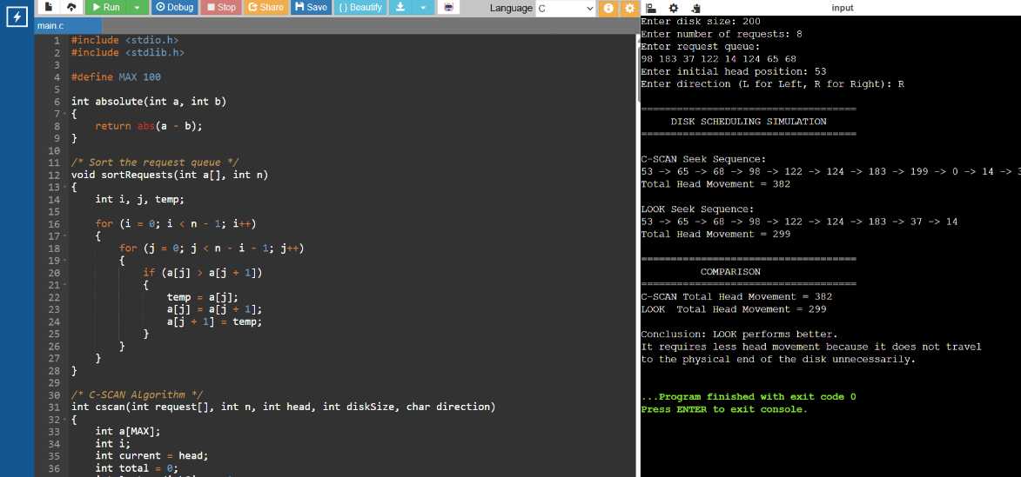
Result
Thus, the C-SCAN and LOOK disk scheduling algorithms were successfully implemented. The program calculates the seek sequence and total head movement for both algorithms and identifies the better-performing algorithm based on minimum head movement. LOOK generally reduces unnecessary movement because it reverses direction at the last pending request instead of travelling to the physical end of the disk.

Q5)
Aim
To design and implement a C program that integrates file allocation strategies and disk scheduling techniques. The program supports Contiguous and Indexed file allocation along with FCFS and SSTF disk scheduling, calculates total seek time, and identifies the best combination.
Concept
The program has two stages:
Stage 1 – File Allocation
- Contiguous: Allocates consecutive free disk blocks.
- Indexed: Allocates one block as an index block and allocates file blocks from available locations.
Stage 2 – Disk Scheduling
- FCFS: Services allocated blocks in their given order.
- SSTF: Services the nearest allocated block from the current head position.

Algorithm
- Read total disk blocks.
- Read file size.
- Read the disk request queue.
- Read initial head position.
- Select Contiguous or Indexed allocation.
- Allocate free blocks without duplication.
- If allocation fails, display an error.
- Use the allocated blocks as disk requests.
- Apply FCFS and SSTF scheduling.
- Calculate total seek time.
- Compare all successful combinations.
- Display the best allocation and scheduling combination.

C Program
#include <stdio.h>
#include <stdlib.h>

#define MAX 100

int disk[MAX];

/* Initialize disk blocks as free */
void initializeDisk(int n)
{
int i;

for (i = 0; i < n; i++)
disk[i] = 0;
}

/* Display allocated blocks */
void displayBlocks(int blocks[], int count)
{
int i;

for (i = 0; i < count; i++)
printf("%d ", blocks[i]);

printf("\n");
}

/* -------------------------------------------------
CONTIGUOUS ALLOCATION
------------------------------------------------- */
int contiguousAllocation(int n, int fileSize, int blocks[])
{
int i, j;
int count;

for (i = 0; i <= n - fileSize; i++)
{
count = 0;

for (j = i; j < i + fileSize; j++)
{
if (disk[j] == 0)
count++;
else
break;
}

if (count == fileSize)
{
for (j = 0; j < fileSize; j++)
{
blocks[j] = i + j;
disk[i + j] = 1;
}

return fileSize;
}
}

return 0;
}

/* -------------------------------------------------
INDEXED ALLOCATION
------------------------------------------------- */
int indexedAllocation(int n, int fileSize, int blocks[])
{
int i;
int count = 0;
int indexBlock = -1;

/* Need one extra block for index */
if (fileSize + 1 > n)
return 0;

/* Find index block */
for (i = 0; i < n; i++)
{
if (disk[i] == 0)
{
indexBlock = i;
disk[i] = 1;
break;
}
}

if (indexBlock == -1)
return 0;

/* Allocate data blocks */
for (i = 0; i < n && count < fileSize; i++)
{
if (disk[i] == 0)
{
blocks[count] = i;
disk[i] = 1;
count++;
}
}

/* If allocation fails, release allocated blocks */
if (count < fileSize)
{
disk[indexBlock] = 0;

for (i = 0; i < count; i++)
disk[blocks[i]] = 0;

return 0;
}

printf("Index Block: %d\n", indexBlock);

return fileSize;
}

/* -------------------------------------------------
FCFS DISK SCHEDULING
------------------------------------------------- */
int fcfs(int blocks[], int n, int head)
{
int i;
int current = head;
int total = 0;

printf("Seek Sequence: %d", head);

for (i = 0; i < n; i++)
{
total += abs(current - blocks[i]);
current = blocks[i];

printf(" -> %d", current);
}

printf("\nTotal Seek Time = %d\n", total);

return total;
}

/* -------------------------------------------------
SSTF DISK SCHEDULING
------------------------------------------------- */
int sstf(int blocks[], int n, int head)
{
int visited[MAX];
int i;
int count;
int current = head;
int total = 0;
int minDistance;
int index;

for (i = 0; i < n; i++)
visited[i] = 0;

printf("Seek Sequence: %d", head);

for (count = 0; count < n; count++)
{
minDistance = 99999;
index = -1;

/* Find nearest unvisited block */
for (i = 0; i < n; i++)
{
if (visited[i] == 0)
{
if (abs(current - blocks[i]) < minDistance)
{
minDistance = abs(current - blocks[i]);
index = i;
}
}
}

if (index == -1)
break;

visited[index] = 1;

total += abs(current - blocks[index]);
current = blocks[index];

printf(" -> %d", current);
}

printf("\nTotal Seek Time = %d\n", total);

return total;
}

/* -------------------------------------------------
MAIN PROGRAM
------------------------------------------------- */
int main()
{
int n;
int fileSize;
int requestQueue[MAX];
int requestCount;
int head;
int i;

int blocks[MAX];
int allocatedCount;

int contigFCFS = -1;
int contigSSTF = -1;
int indexedFCFS = -1;
int indexedSSTF = -1;

int minSeek = 99999;
int bestAllocation = 0;
int bestScheduling = 0;

/* Input disk size */
printf("Enter total number of disk blocks: ");
scanf("%d", &n);

if (n <= 0 || n > MAX)
{
printf("Invalid disk size.\n");
return 0;
}

/* Input file size */
printf("Enter file size (number of blocks required): ");
scanf("%d", &fileSize);

if (fileSize <= 0 || fileSize > n)
{
printf("Invalid file size.\n");
return 0;
}

/* Input disk request queue */
printf("Enter number of disk requests: ");
scanf("%d", &requestCount);

if (requestCount < 0 || requestCount > MAX)
{
printf("Invalid request count.\n");
return 0;
}

printf("Enter disk request queue:\n");

for (i = 0; i < requestCount; i++)
{
scanf("%d", &requestQueue[i]);

if (requestQueue[i] < 0 || requestQueue[i] >= n)
{
printf("Invalid disk request: %d\n", requestQueue[i]);
return 0;
}
}

/* Input head */
printf("Enter initial head position: ");
scanf("%d", &head);

if (head < 0 || head >= n)
{
printf("Invalid head position.\n");
return 0;
}

/* ------------------------------------------------
CONTIGUOUS ALLOCATION
------------------------------------------------ */

initializeDisk(n);

printf("\n====================================");
printf("\nCONTIGUOUS ALLOCATION");
printf("\n====================================\n");

allocatedCount = contiguousAllocation(n, fileSize, blocks);

if (allocatedCount == 0)
{
printf("Contiguous allocation failed.\n");
printf("Insufficient continuous free space.\n");
}
else
{
printf("Allocated Blocks:\n");
displayBlocks(blocks, allocatedCount);

printf("\n--- Contiguous + FCFS ---\n");
contigFCFS = fcfs(blocks, allocatedCount, head);

printf("\n--- Contiguous + SSTF ---\n");
contigSSTF = sstf(blocks, allocatedCount, head);
}

/* ------------------------------------------------
INDEXED ALLOCATION
------------------------------------------------ */

initializeDisk(n);

printf("\n====================================");
printf("\nINDEXED ALLOCATION");
printf("\n====================================\n");

allocatedCount = indexedAllocation(n, fileSize, blocks);

if (allocatedCount == 0)
{
printf("Indexed allocation failed.\n");
printf("Insufficient free blocks.\n");
}
else
{
printf("Allocated Data Blocks:\n");
displayBlocks(blocks, allocatedCount);

printf("\n--- Indexed + FCFS ---\n");
indexedFCFS = fcfs(blocks, allocatedCount, head);

printf("\n--- Indexed + SSTF ---\n");
indexedSSTF = sstf(blocks, allocatedCount, head);
}

/* ------------------------------------------------
PERFORMANCE COMPARISON
------------------------------------------------ */

printf("\n====================================");
printf("\nPERFORMANCE COMPARISON");
printf("\n====================================\n");

if (contigFCFS != -1)
printf("Contiguous + FCFS = %d\n", contigFCFS);
else
printf("Contiguous + FCFS = Allocation Failed\n");

if (contigSSTF != -1)
printf("Contiguous + SSTF = %d\n", contigSSTF);
else
printf("Contiguous + SSTF = Allocation Failed\n");

if (indexedFCFS != -1)
printf("Indexed + FCFS = %d\n", indexedFCFS);
else
printf("Indexed + FCFS = Allocation Failed\n");

if (indexedSSTF != -1)
printf("Indexed + SSTF = %d\n", indexedSSTF);
else
printf("Indexed + SSTF = Allocation Failed\n");

/* Find minimum */
if (contigFCFS != -1 && contigFCFS < minSeek)
{
minSeek = contigFCFS;
bestAllocation = 1;
bestScheduling = 1;
}

if (contigSSTF != -1 && contigSSTF < minSeek)
{
minSeek = contigSSTF;
bestAllocation = 1;
bestScheduling = 2;
}

if (indexedFCFS != -1 && indexedFCFS < minSeek)
{
minSeek = indexedFCFS;
bestAllocation = 2;
bestScheduling = 1;
}

if (indexedSSTF != -1 && indexedSSTF < minSeek)
{
minSeek = indexedSSTF;
bestAllocation = 2;
bestScheduling = 2;
}

if (minSeek == 99999)
{
printf("\nNo successful allocation/scheduling combination.\n");
}
else
{
printf("\n====================================");
printf("\nBEST COMBINATION");
printf("\n====================================\n");

if (bestAllocation == 1)
printf("Allocation Method : Contiguous\n");
else
printf("Allocation Method : Indexed\n");

if (bestScheduling == 1)
printf("Scheduling Method : FCFS\n");
else
printf("Scheduling Method : SSTF\n");

printf("Minimum Seek Time : %d\n", minSeek);
}

return 0;
}
OUTPUT
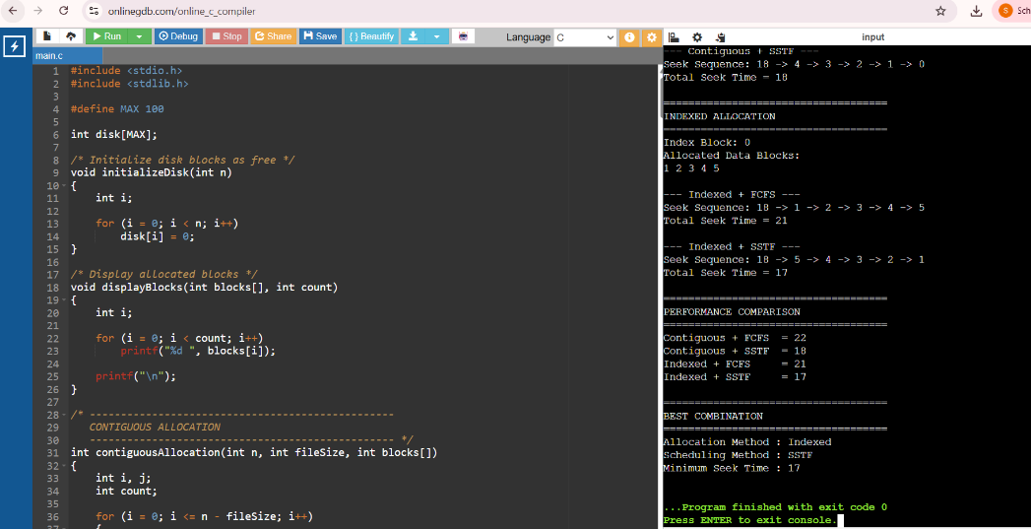

Result
Thus, the program successfully integrates Contiguous and Indexed file allocation with FCFS and SSTF disk scheduling. It allocates blocks without duplication, detects allocation failures, calculates the seek sequence and total seek time, and identifies the combination with the minimum seek time as the best-performing combination.

